COVID-19 PHASE 2
BUSINESS CONTINUITY PLAN

[SOCIETY NAME]

FACILITY: |  | LOCATION:
FACIITY TYPE: | (e.g. Office, Residential, Program Site, Shelter, etc.) | MANAGER:

COVID-19 coronavirus is highly contagious and implementing measures and controls in the workplace is essential to prevent its spread. The purpose of this Planning Template is to identify and implement risk mitigation measures and controls specific to each site maintained and operated by [Society Name] in accordance with OHS requirements, government emergency orders and current public health guidelines for as long as the pandemic lasts.
The process for identifying and putting in place efforts to contain COVID-19 involves a walk-through risk assessment, identification of measures and controls that are incorporated into a site-specific business continuity plan. [Society Name] will take steps ensure that all actions identified in the business continuity plan are put into effect and that the plan is broadly communicated, and employees are properly trained.

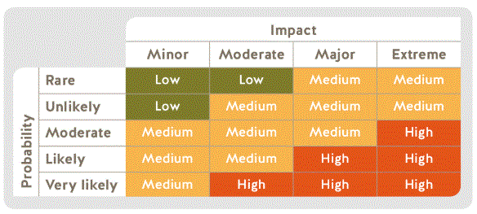 | Conduct a walk-through assessment of each facility operated by the Society determining the level risk of exposure to the COVID-19 virus rated as High, Medium & Low based on the probability of transmission and the impact assuming no controls are in place.  Children’s Play areas (inside) Parkades  Children’s Play areas (outside) Photocopier equipment  Entry points Program offices  Elevators Stairways & Landings  Meal Service areas Service Counters  Meeting areas Shelter- Overnight areas  Mailroom Supply rooms  On-site kitchen Waiting areas  Patios Washrooms
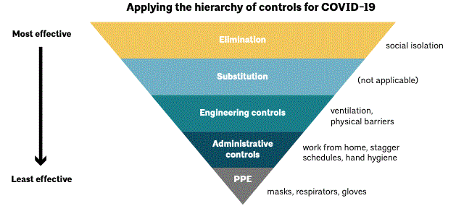 | Identify control measures (or the absence of control measures) for each area of the facility. Use the attached schedules to record actions you intend to put into effect.  Record the following information:  - Facility/Site Name  - Work Area (e.g. Service desk, lunchroom, boardroom, playground, etc.)  - Threat Level – High, Medium, Low  - Risk Assessor  - Health & Safety Rep  - Site Supervisor  - Date  Monitor and regularly assess the effectiveness of the controls. Make adjustments as needed depending upon the amount of traffic in the area and the incidence of infection.  Facility includes offices, program sites, apartment and multi-residential buildings,  shelters, playgrounds, etc.

Facility: |  | Risk Assessor: |  | Date:
Work Area: |  | Health & Safety Rep: |  | yyyy-mm-dd
Threat Level: |  | Site Supervisor:

Risk Controls | Assigned To | Sign-off  (by Assigned to)  Yes No N/A |  |  | Comments
- Staffing
- Determine essential staffing needs
- Recall employees on temporary layoff
- Pre-screen returning employees using the Health Screening Questionnaire
- Determine accommodation needs on a case-by-case basis
- Identify and check in with employees on COVID-19 related leave
- Redeploy staff where needed
- Recruit temporary employees or summer students if needed
- Communicate COVID-19 Policies & Protocols
- COVID-19 Sick Leave Policy
- Works Refusals Protocol
- New Office forms & procedures (e.g. health screening for visitors, Logbook, etc.)
- Physical Distancing Measures
- Site Sanitization Schedule & Protocols
- Train staff on COVID-19 restrictions, protocols and proper hygiene & use of PPE
- Hygiene / Cleaning Measures
- Work surfaces are disinfected at appropriate intervals
- Equipment are decontaminated before and after use
- Handwashing is done on entering and leaving the workplace, after removing PPE.
- Hand sanitizer is available
- Eliminate frequent contact of surfaces (e.g. leave door(s) open where possible)
- Remove appliances, dishes, cutlery, glassware and other commonly used items; staff bring their own
- Hygiene / cleaning measures
- Work surfaces are disinfected at appropriate intervals
- Physical Distancing
- Identify and post occupancy limits
- Stagger lunch/breaks
- Stagger hours of work
- Establish work from home arrangements
- Discourage physical contact of employees
- Discourage events and gathering in excess of 50 people adhering to physical distancing guidelines.
- Limit number of passengers in vehicle
- Place floor markers spaced at 2 metres (6 feet) apart in wait areas
- Place directional markers to regulate flow in line-ups
- Secure or restrict access to small areas
- Post and monitor occupancy limit in elevator
- Remove seating in wait areas
- Other actions
- Engineering control measures
- HVAC systems functioning
- Plexiglas barriers installed
- Physical barriers erected
- Office workstations are reconfigured to ensure maximum distance between employees
- Cordon off playground areas with caution tape
- Identify and secure access to area in open shelter space for isolating sick clients
- Administrative Controls
- Eliminate ‘Wait’ Area, Book Appointments instead
- Establish a Visitor Screening Protocol
- Set up a Visitor Log In/Out System
- Secure IT for email, web meetings & file sharing
- Designate a Delivery Drop Zone
- Identify & Post Signage (e.g. Restricted access, Occupancy Limits, Hygiene Reminders, etc.)
- Set up and run temperature screening of all non-employees
- Establish and circulate a site sanitization guideline & schedule
- Reliable and sustainable source for procurement of supplies, including PPE, disinfectant, sanitizer, hand soap, disposable paper towel
- Adequate supplies of PPE, sanitary materials, and cleaning products
- Other
- Personal Protective Equipment
- Masks
- Gloves
- Face Shields/Goggles
- Other:
- Emergency Response
- Response plan in case someone shows symptoms of COVID-19 in the workplace
- Suspected COVID-19 case isolation areas and protocols
- System to track and trace potential interactions
- Additional Measures (unique to this facility)

